Penetration Testing Report

# Revision

Version 6

10/27/22 1:59 PM

# SME

Lucky Munro, Process

Charles Wilson, Process

Matthew Bourdua, Report

# Abstract

This document describes the process used to produce a penetration testing report.

# Group / Owner

Security / Vulnerability Assessment Analyst

# Motivation

This document is motivated by the need to have whole-system, security-related feedback in the development of safety-critical, cyber-physical systems for certification of compliance to standards such as **ISO 21434** and **ISO 26262**.

# License

This work was created by **Motional** and is licensed under the **Creative Commons Attribution-Share Alike (CC BY-SA-4.0)** License.

[**https://creativecommons.org/licenses/by/4.0/legalcode**](https://creativecommons.org/licenses/by/4.0/legalcode)

# Overview

Although the quality of feedback from the compiler, static and dynamic analysis tools, and fuzz testing provides a great deal of insight into security-related issues, they generally only expose possible security issues. Penetration testing provides analysis into possible real-world attacks on the system as a whole and exploits only achievable through taking advantage of multiple security deficiencies.

The following shows the workflow used:

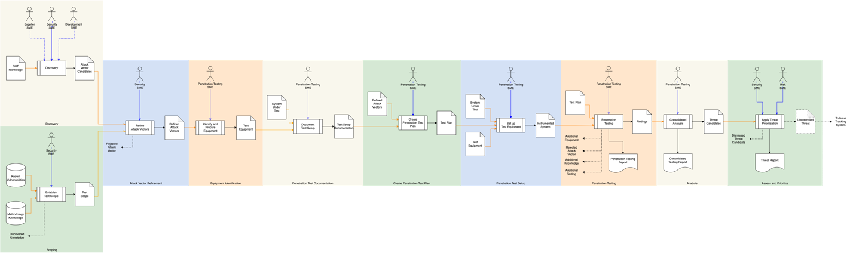

# Process

## Discovery

|  |  |
| --- | --- |
| **Inputs** | SUT knowledge |
| **Outputs** | Attack vector candidates |
| **Participants** | Security SME  Supplier SME (optional)  Development SME (optional) |

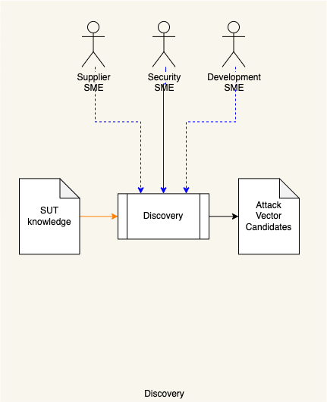

The Security SME with the possible assistance of the Supplier SME and Development SME review the **SUT knowledge** and create a list of **Attack Vector Candidates** to be used for penetration testing.

**Note:** This activity can be done in parallel with the **Scoping** activity.

## Scoping

|  |  |
| --- | --- |
| **Inputs** | Known vulnerabilities  Methodology knowledge |
| **Outputs** | Test scope |
| **Participants** | Security SME |

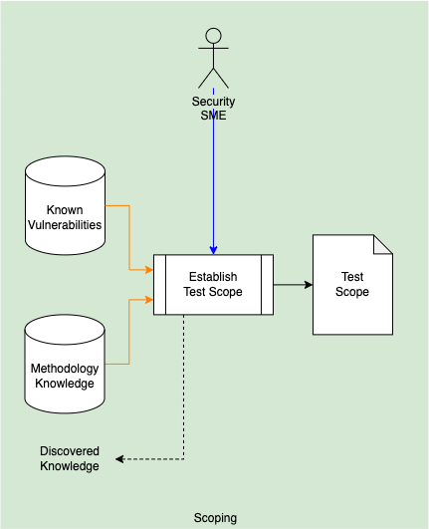

Using the **Known Vulnerabilities** of the system to be tested and penetration testing **Methodology Knowledge [4, 5, 6, 7]**, the Security SME establishes a scope for the penetration testing efforts which is documented in the **Test Scope** document. If new understanding of the system to be tested is discovered, a **Discovered Knowledge** notification is generated.

**Note:** The **Discovered Knowledge** notification is a conceptual construct. In practice, steps will be taken to integrate this new information into the **SUT knowledge**.

**Note:** This activity can be done in parallel with the **Discovery** activity.

## Attack Vector Refinement

|  |  |
| --- | --- |
| **Inputs** | Attack vector candidates  Test scope |
| **Outputs** | Refined attack vectors |
| **Participants** | Security SME |

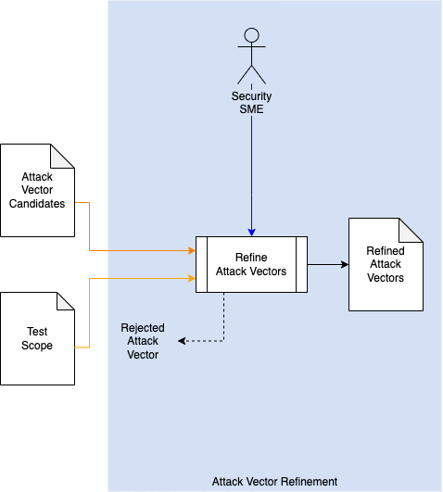

Using the **Test Scope**, the Security SME refines the **Attack Vector Candidates** to those applicable to the scope. A **Refined Attack Vectors** list is generated. If an attack vector is rejected for reasons other than scope, a **Rejected Attack Vector** notification is generated.

**Note:** The **Rejected Attack Vector** notification is a conceptual construct. In practice, steps will be taken to integrate this information into the **SUT knowledge**.

## Equipment Identification

|  |  |
| --- | --- |
| **Inputs** | Refined attack vectors |
| **Outputs** | Test equipment |
| **Participants** | Penetration testing SME |

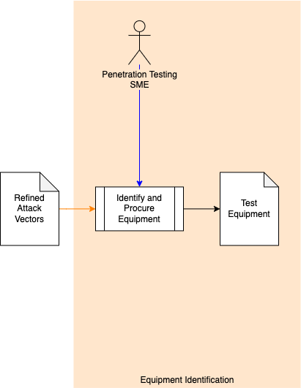

Using the **Refined Attack Vectors**, the Penetration Testing SME identifies and procures the equipment necessary to carry out the penetration testing. A **Test Equipment** list is generated.

## Penetration Test Documentation

|  |  |
| --- | --- |
| **Inputs** | System under test  Test equipment |
| **Outputs** | Test setup documentation |
| **Participants** | Penetration testing SME |

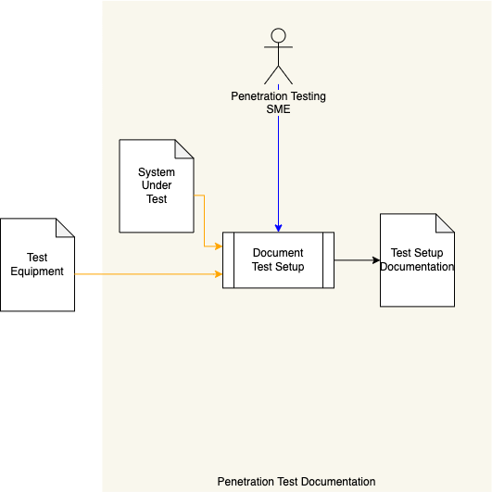

Using the **Test Equipment** list, the Penetration Testing SME reviews the **System Under Test** to determine how the system should be instrumented with the **Test Equipment**. A **Test Setup Documentation** document is generated.

## Create Penetration Test Plan

|  |  |
| --- | --- |
| **Inputs** | Test setup documentation  Refined attack vectors |
| **Outputs** | Test plan |
| **Participants** | Penetration testing SME |

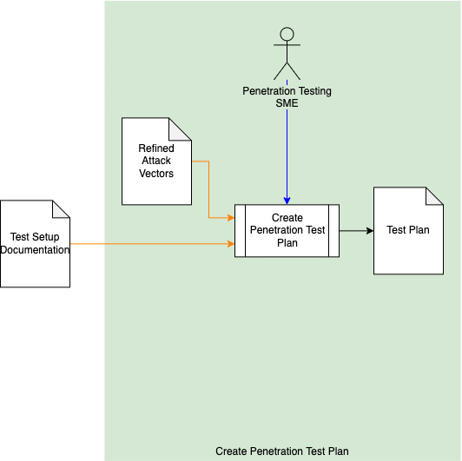

Using the **Test Setup Documentation** and **Refined Attack Vectors**, the Penetration Testing SME creates a plan to be used for penetration testing. A **Test Plan** document is generated.

## Penetration Test Setup

|  |  |
| --- | --- |
| **Inputs** | System under test  Test plan  Test equipment |
| **Outputs** | Instrumented system |
| **Participants** | Penetration testing SME |

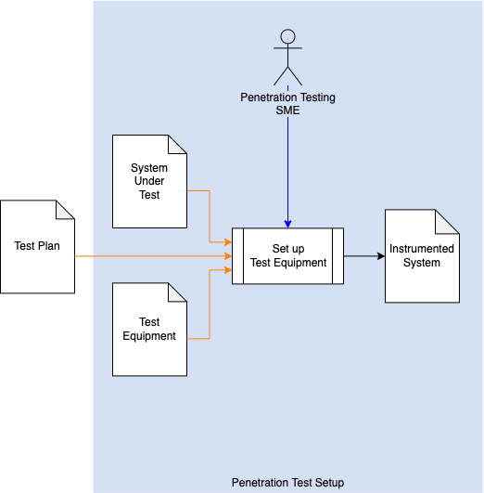

Using the **Test Plan**, the Penetration Testing SME assembles the **System Under Test** and **Test Equipment**. This results in the creation of an **Instrumented System** to be used during penetration testing.

## Penetration Testing

|  |  |
| --- | --- |
| **Inputs** | Test plan  Instrumented system |
| **Outputs** | Findings  Penetration testing report |
| **Participants** | Penetration testing SME |

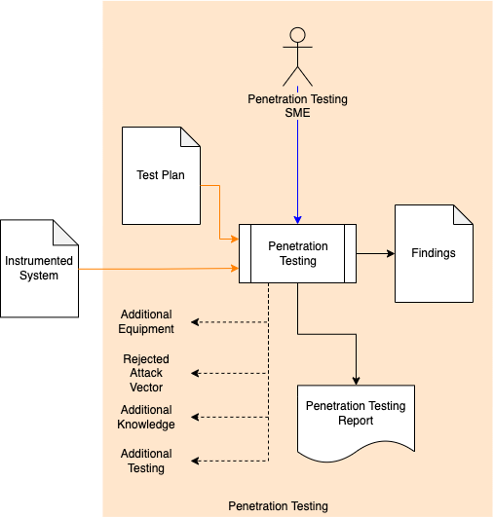

Using the **Instrumented System**, the Penetration Testing SME follows the **Test Plan** to perform penetration testing on the SUT. A **Findings** list is generated. From the **Findings**, a **Penetration Testing Report** is generated. If additional equipment is necessary, an attack vector is rejected, additional knowledge of the system is gained, or additional testing is required, an appropriate notification is generated.

**Note:** The notifications generated here are a conceptual construct. In practice, steps will be taken to integrate this information into the **SUT knowledge** and **Methodology Knowledge**.

**Note:** The Penetration Testing SME may add issue remediation recommendations to the individual **Threat Candidates**.

### Findings

The recommended form of the **Findings** artifact is a Static Analysis Results Interchange Format (**SARIF**) encoded JSON. This document assumes SARIF version 2.1.0 **[3]** or later.

### Penetration Testing Report

The **Penetration Testing Report** is recommended to be produced from the **Findings** artifact and should detail the issues exposed by the penetration testing.

The report should be organized into a summary section and a list of one or more runs. The summary section includes:

* A use case indicator (penetration test findings)

Each run includes:

* Description of the test (copied from the test plan)
* Reference to the refined attack vectors document (typically a URI)
* Reference to the test equipment document (typically a URI)
* Reference to the test setup document (typically a URI)
* Reference to the test plan document (typically a URI)
* Reference to the instrumented system document (typically a URI)
* Timestamp, indicating when the test started (ISO 8601)
* The individual performing the test (email address)
* A list of one or more results

Each result contains:

* Description of the test performed (copied from the test plan)
* Enumerated test result (typically pass or fail)
* Test ID (from the test plan)
* The expected result of the test (copied from the test plan)
* Indication of whether the test ran to completion (Boolean)
* Indication of whether the test passed (Boolean)

If the test result indicates a failure, the result shall additionally include:

* Description of the actual result
* A list of one or more findings

## Analysis

|  |  |
| --- | --- |
| **Inputs** | Findings |
| **Outputs** | Threat Candidates  Consolidated Testing Report |
| **Participants** | Penetration testing SME |

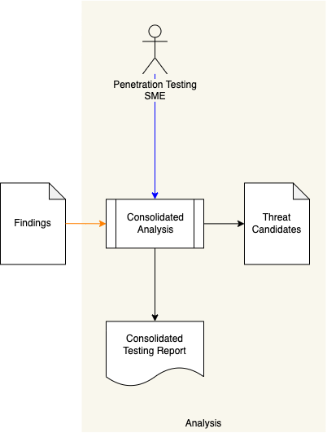

Using the **Findings** from all the penetration testing effort, the Penetration Testing SME performs a consolidated analysis of the aggregate findings. A list of **Threat Candidates** is produced. A **Consolidated Testing Report** is generated.

## Assess and Prioritize

|  |  |
| --- | --- |
| **Inputs** | Threat Candidates |
| **Outputs** | Uncontrolled Threat  Threat Report |
| **Participants** | Security SME  Risk SME |

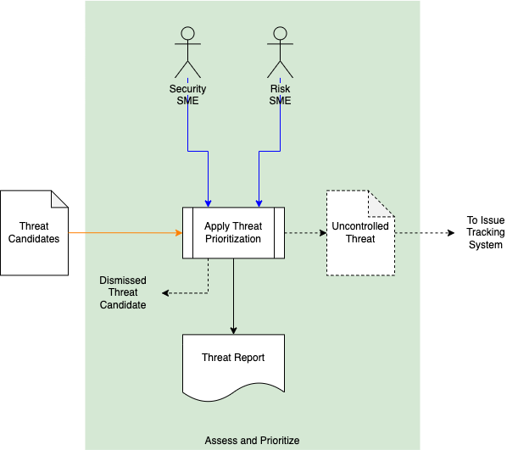

The Security SME will take each **Threat Candidate** and apply the **Threat Prioritization Plan**. The **Threat Candidate’s** rank and risk will be assigned by the Security SME and Risk SME respectively. A **Threat Report** documenting the findings will be generated. If the threat is determined to be controlled a **Dismissed Threat Candidate** notification will be generated. If the threat is determined to be uncontrolled, an **Uncontrolled Threat** will be generated.

**Note:** The **Dismissed Threat Candidate** notification is a conceptual construct. In practice, steps will be taken to integrate this new information into the **SUT knowledge**.

# References

1. **Threat Prioritization Plan (**AVCDL secondary document)
2. **Threat Report (**AVCDL secondary document**)**
3. **Static Analysis Results Interchange Format (SARIF) Version 2.1.0**<https://docs.oasis-open.org/sarif/sarif/v2.1.0/os/sarif-v2.1.0-os.pdf>
4. **The Open Source Security Testing Methodology Manual**  
   <https://www.isecom.org/OSSTMM.3.pdf>
5. NIST SP 800-115: **Technical Guide to Information Security Testing and Assessment**  
   <https://csrc.nist.gov/publications/detail/sp/800-115/final>
6. **Penetration Testing Execution Standard**  
   <http://www.pentest-standard.org/index.php/Main_Page>
7. **PCI Data Security Standard**  
   <https://www.pcisecuritystandards.org/documents/Penetration-Testing-Guidance-v1_1.pdf>